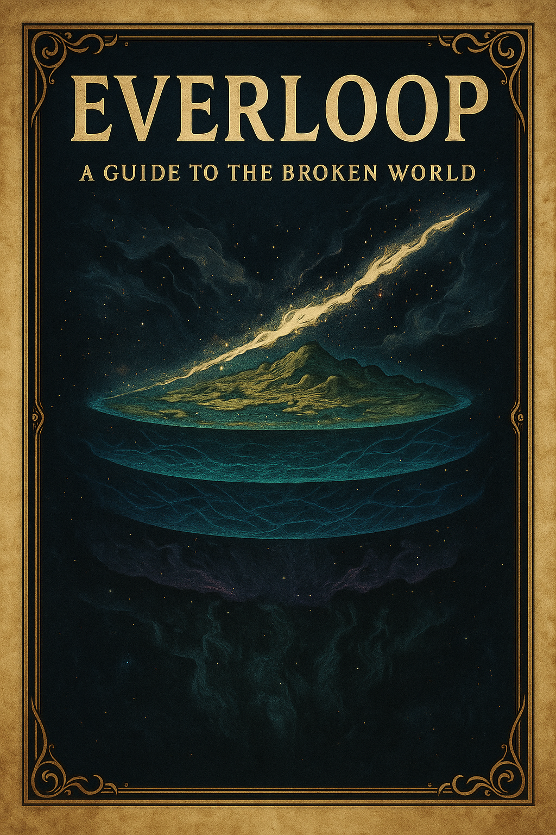

Everloop: A Guide to the Broken World

Reader’s Guide to the Everloop
A Glossary of the World as It Is Known

Core Foundations
The Drift
The origin of everything. A boundless state where matter and intent have no fixed form. Nothing within it remains stable for long.

The Prime Beings
Vast forces that moved within the Drift before the world existed. Not creators, but concentrations of instinct—Hunger, Storm, Silence, Birth. Their current state is unknown.

The Fold
The boundary where chaos first slowed enough for form to persist. It is where the first stable existence became possible.

The First Architects
The first beings to remain themselves over time. They shaped the conditions that allow reality to exist and later became part of its foundation.

The First Map
The initial structure created by the First Architects. Not a physical map, but a framework that defines how things can exist and relate to one another.

The Pattern
The underlying structure of reality. It allows time to move forward, matter to remain consistent, and memory to persist.

The Anchors
The First Architects, fixed into the Pattern to hold it stable. They are no longer active beings, but the foundation that keeps reality from collapsing.

The Everloop
The living world. The surface layer where life, memory, and events take place, supported by the Pattern beneath it.

Current Instabilities
Hollows
Areas where the Pattern has weakened. Reality fades, skips, or fails to continue. People and places may disappear without clear cause.

The Fray
Areas where reality becomes unstable in the opposite way. Time overlaps, events conflict, and cause and effect break down.

The Shards
Fragments of the Anchors created when they were broken. Each still carries stabilizing force, but without balance. They can hold reality in place, but often distort it.

Historical Event
The Rogue Architects
A group of Vaultkeepers and Dreamers who attempted to repair the failing Pattern. Their actions resulted in the destruction of the Anchors and the current state of the world.

Those Who Perceive More
Vaultkeepers
Individuals who can sense or interpret the underlying structure of reality. They often understand that something is wrong, but not how to fix it.

Dreamers
Individuals who can subtly influence reality. Their actions can shift outcomes, but often create unintended consequences elsewhere.

Common Observations
- The world is not uniformly stable
- Some regions behave normally, others do not
- Memory, time, and causality may be unreliable in certain areas
- Most people are unaware of the larger structure or its failure

Current State of the World
The Everloop continues to exist, but the Pattern beneath it is weakening.
Hollows are increasing.
The Fray is spreading.
Shards remain scattered.
No confirmed method exists to fully restore stability.

Open Questions
- Why did the Pattern begin to fail?
- What happened to the Prime Beings?
- Do the First Architects still exist in any form?
- Can the Shards be used to restore balance, or only to delay collapse?

